**VARRAY->Array store same datatypes.at the time declare section we need to specify size.**

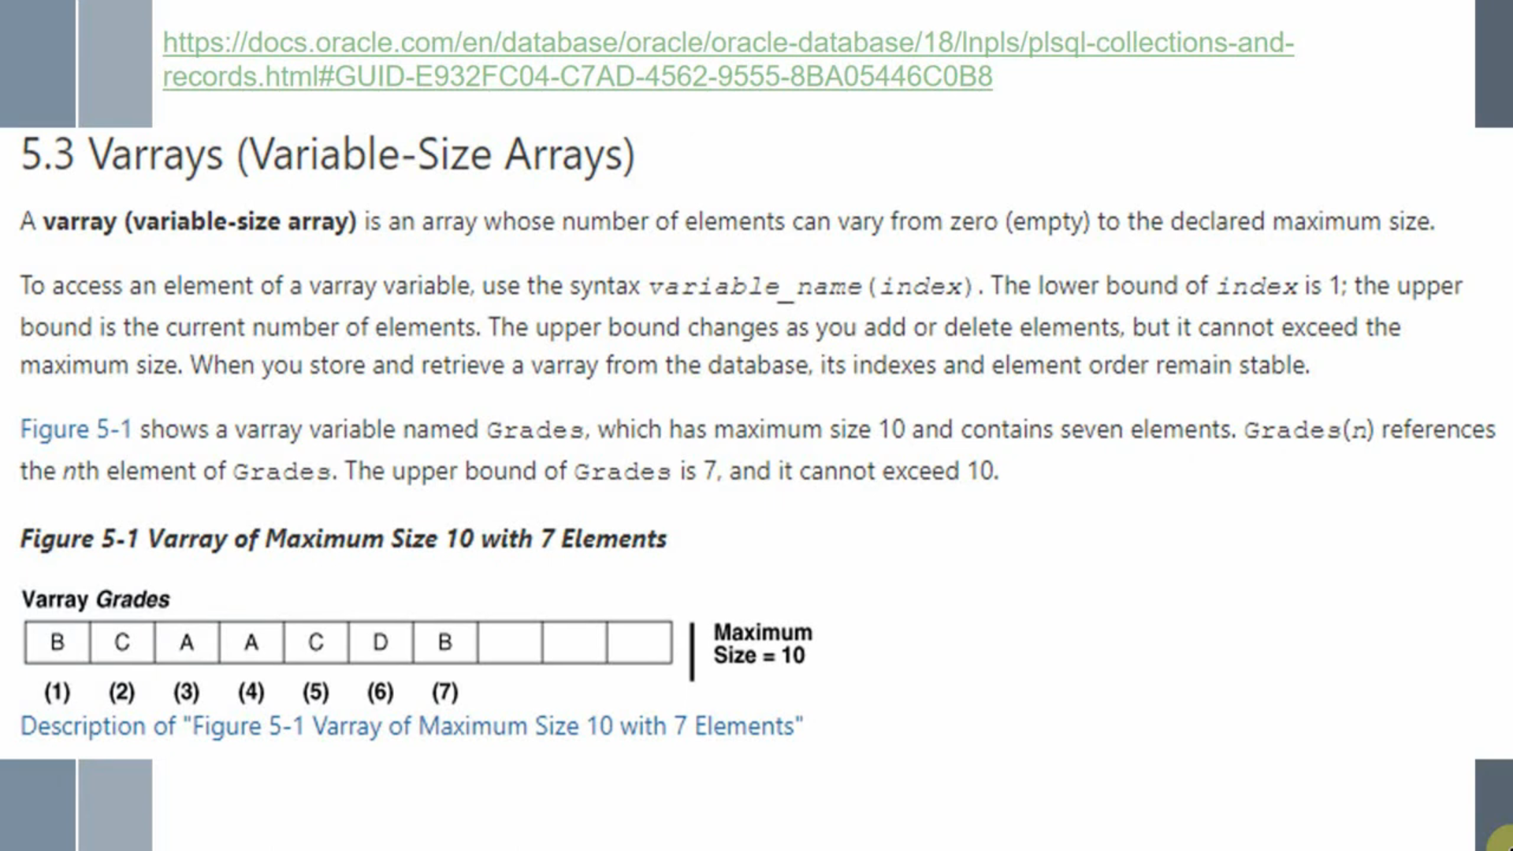

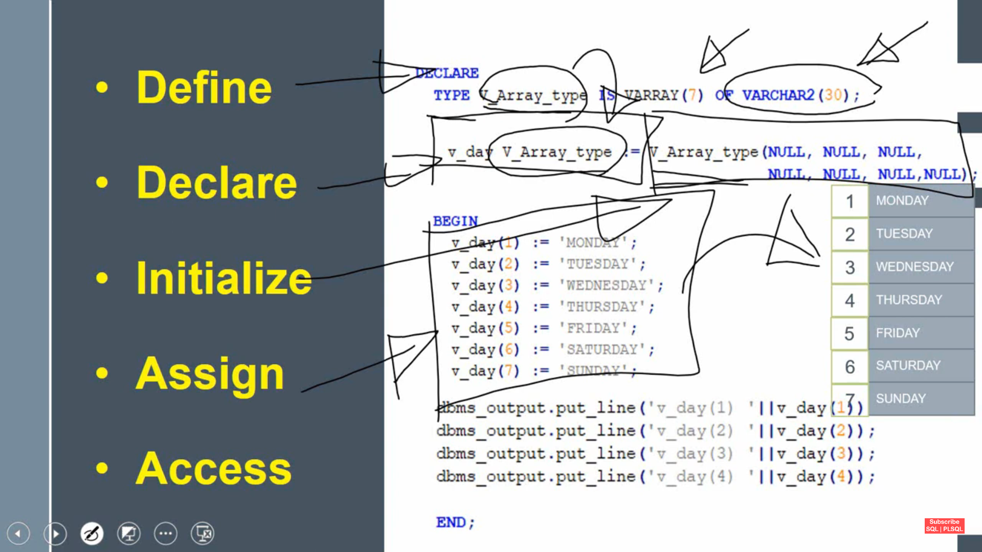

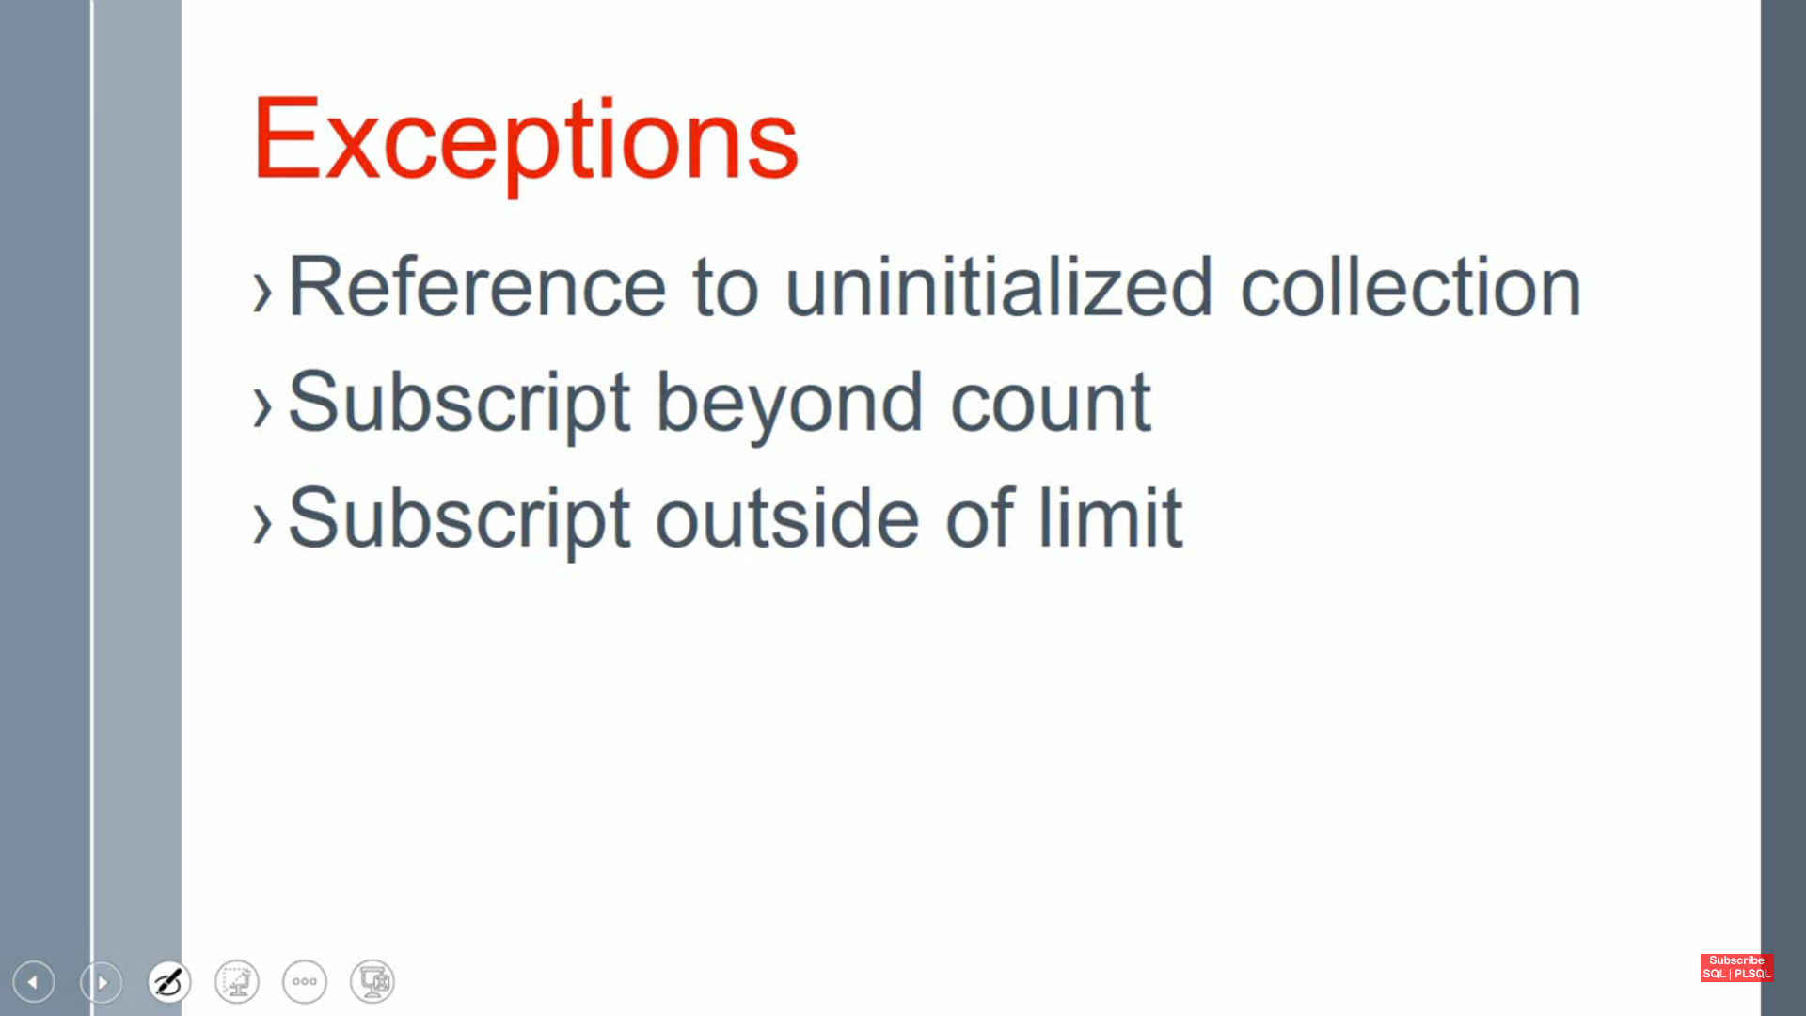

**While initializing we need to mention constructor also same size(Varray size)otherwise if we give one element in constructor we can assign only one element to that array**

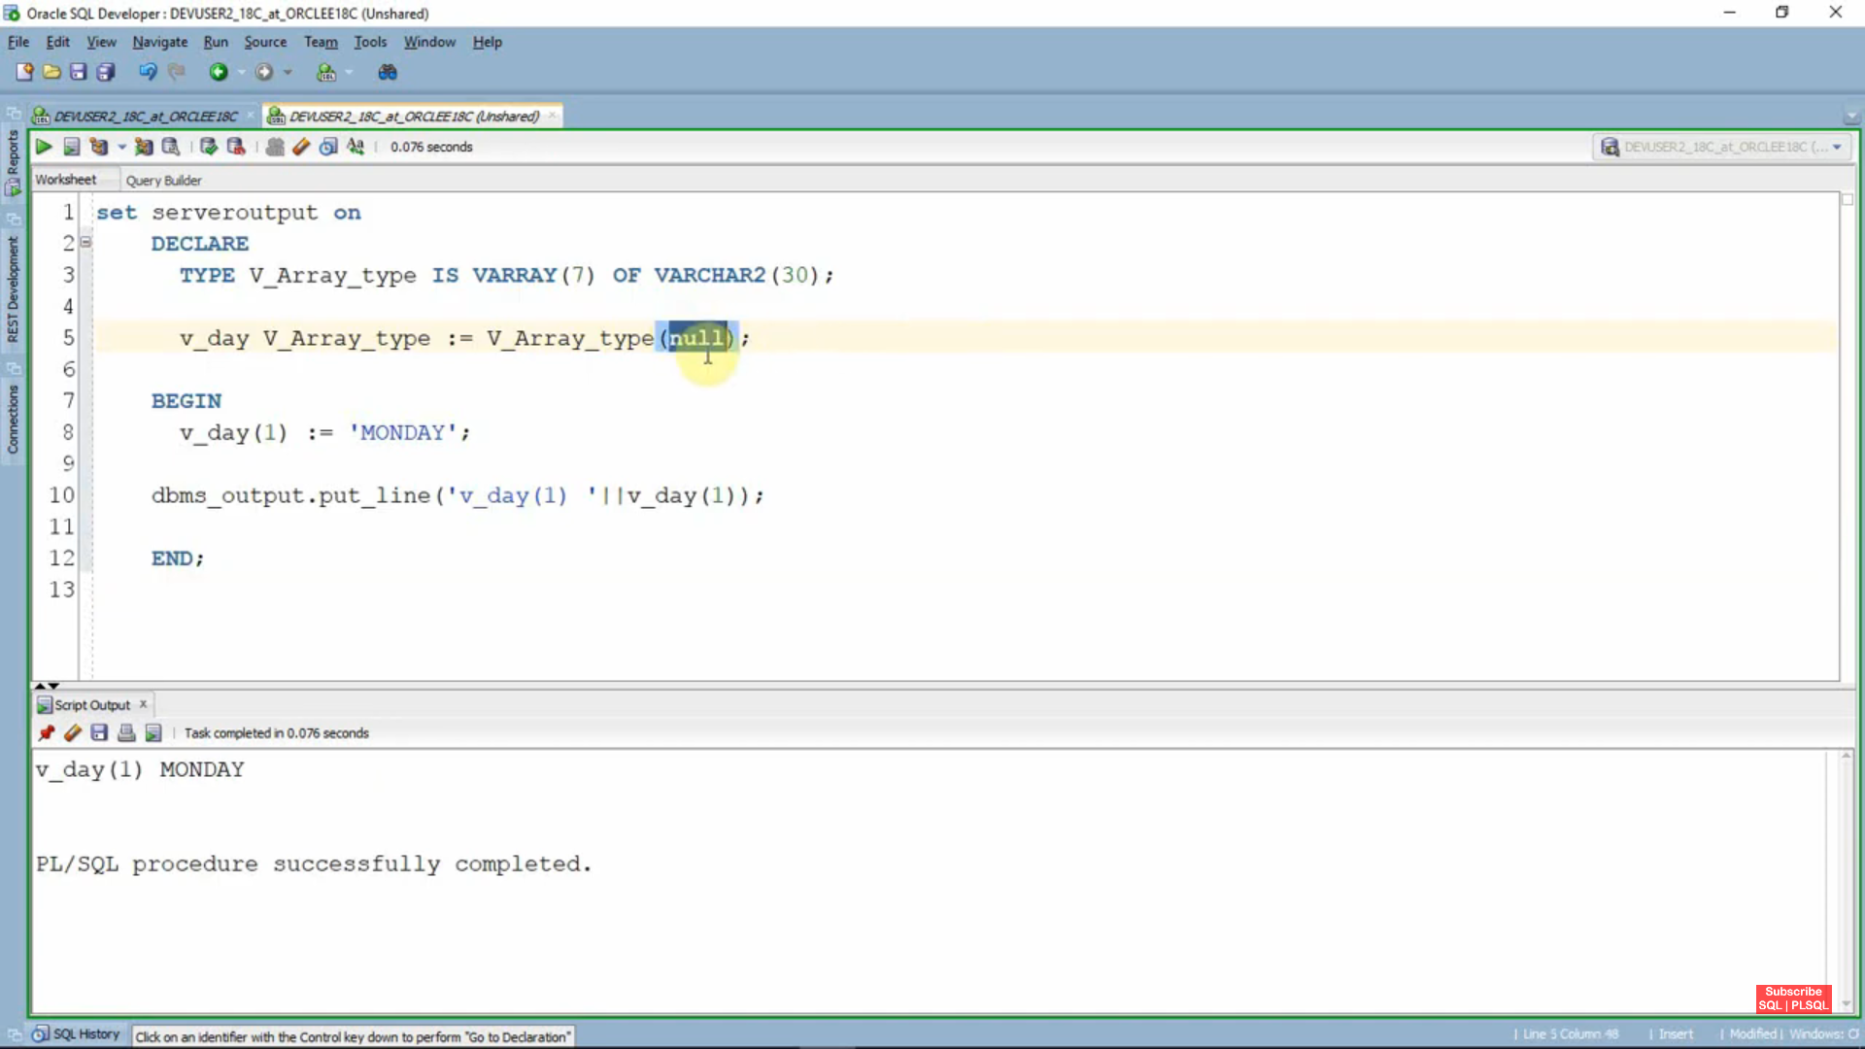

**if we give one element in constructor if we try to assign two element to that array its give error subscript beyond count**

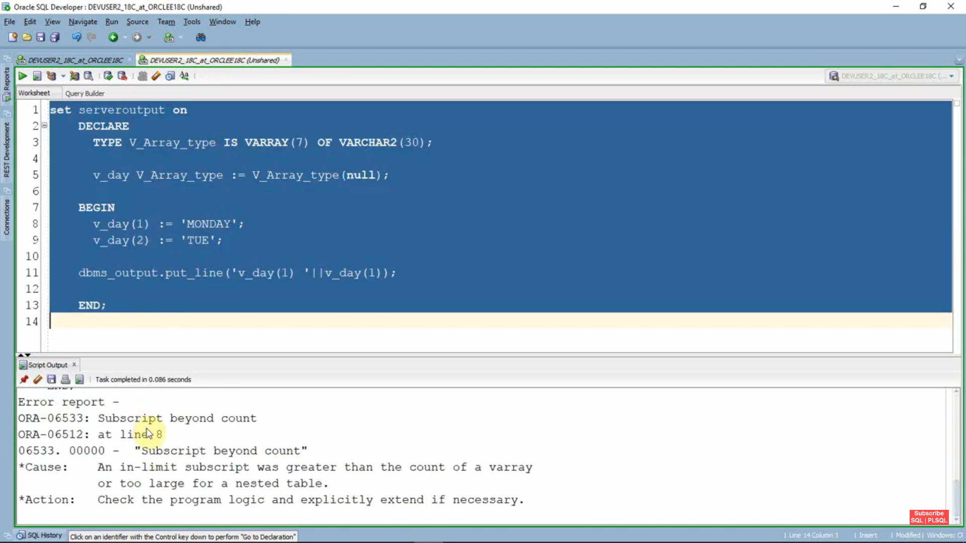

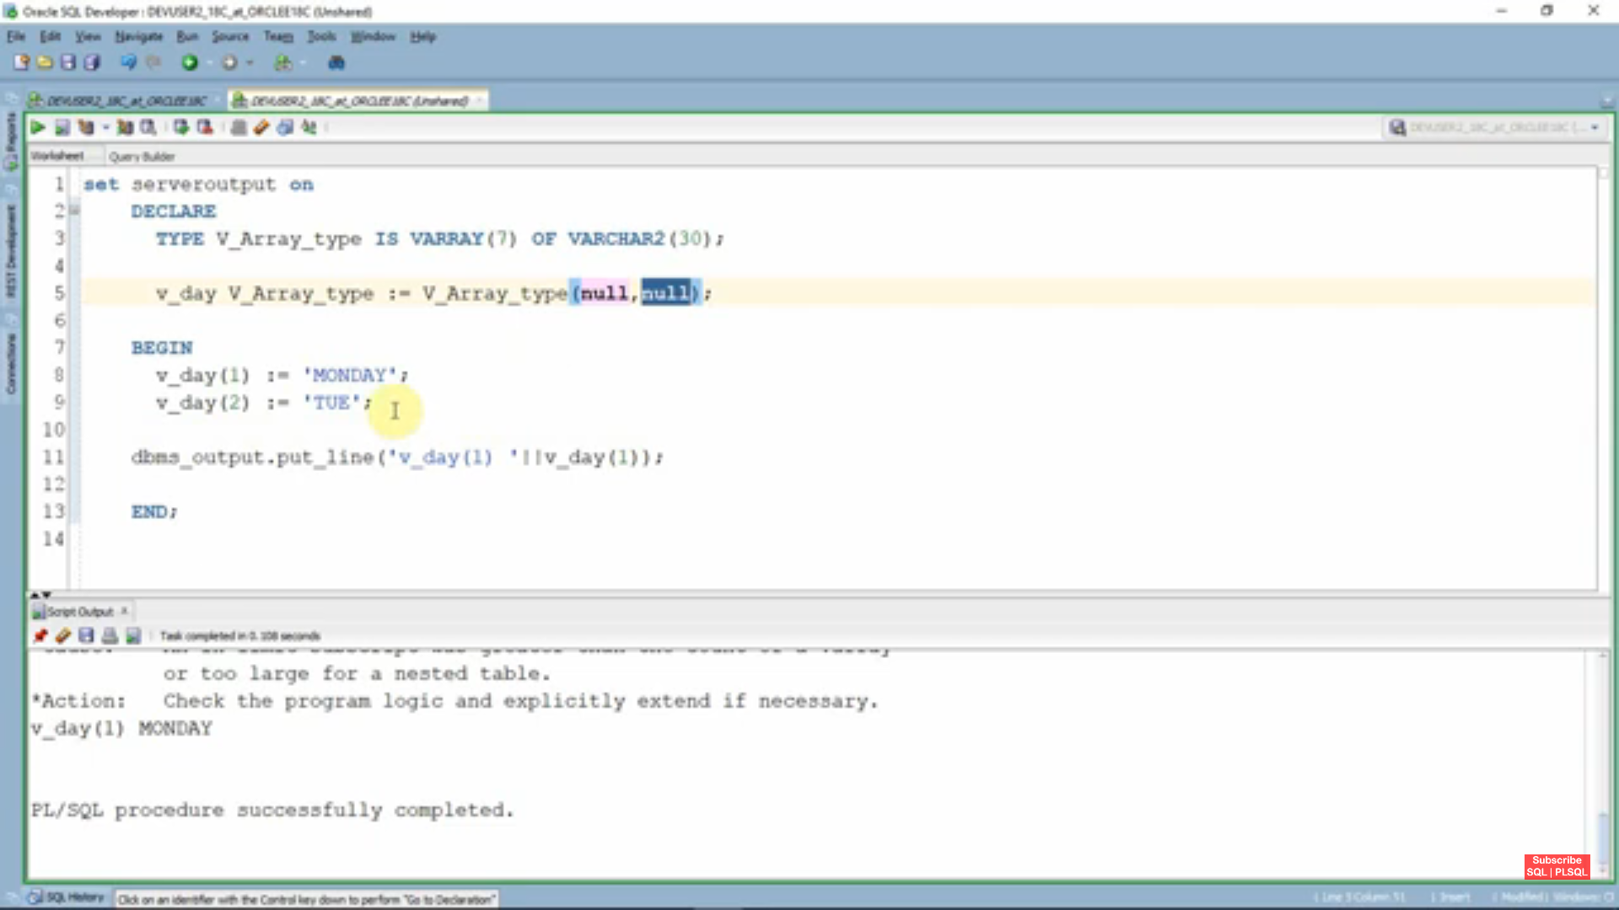

if we give one element in constructor if we try to assign two element to that array its give error **subscript beyond count** to avoid that we need to us **extend()**

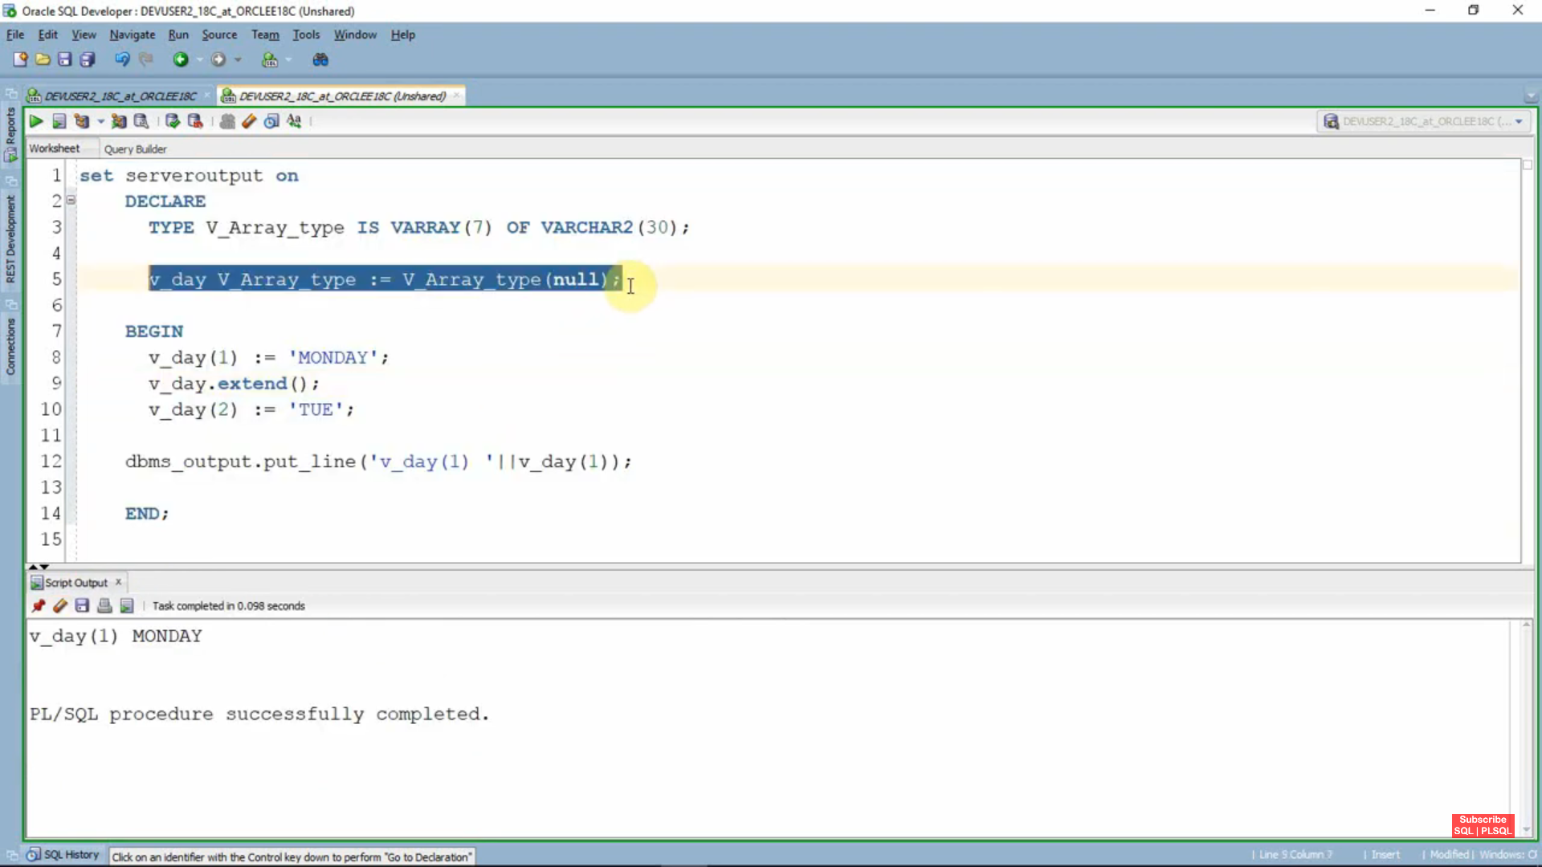

**2nd exception**

if we are not initializing elements in constructor if we try to assign element to that array its give error **Reference to Uninitialized Collection.**

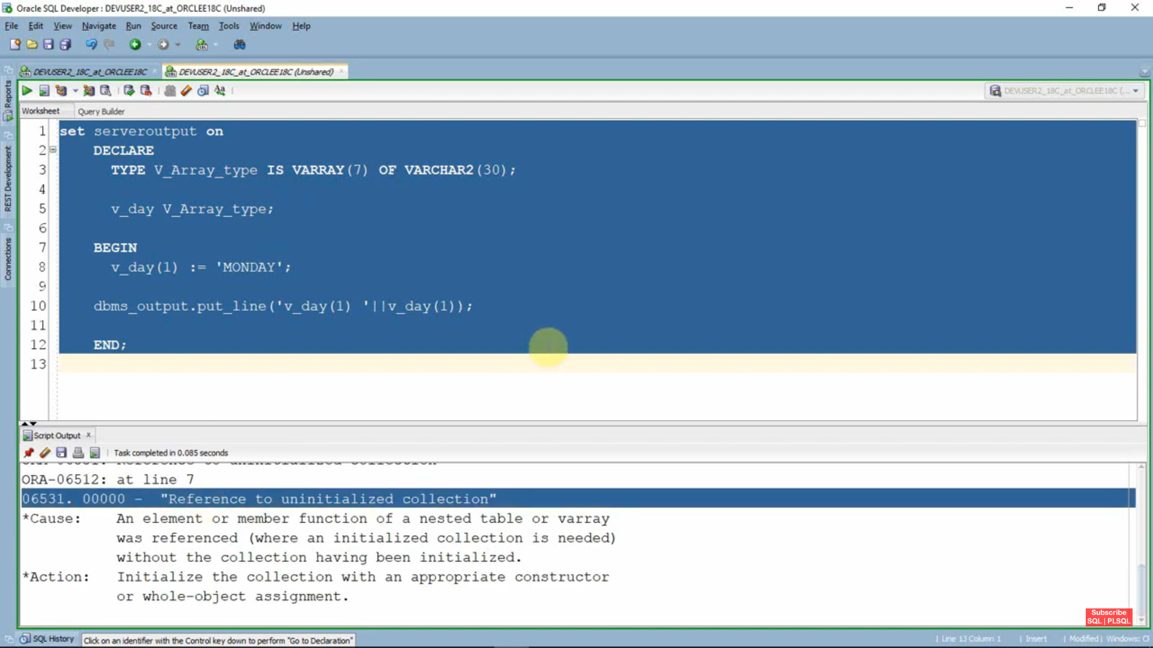

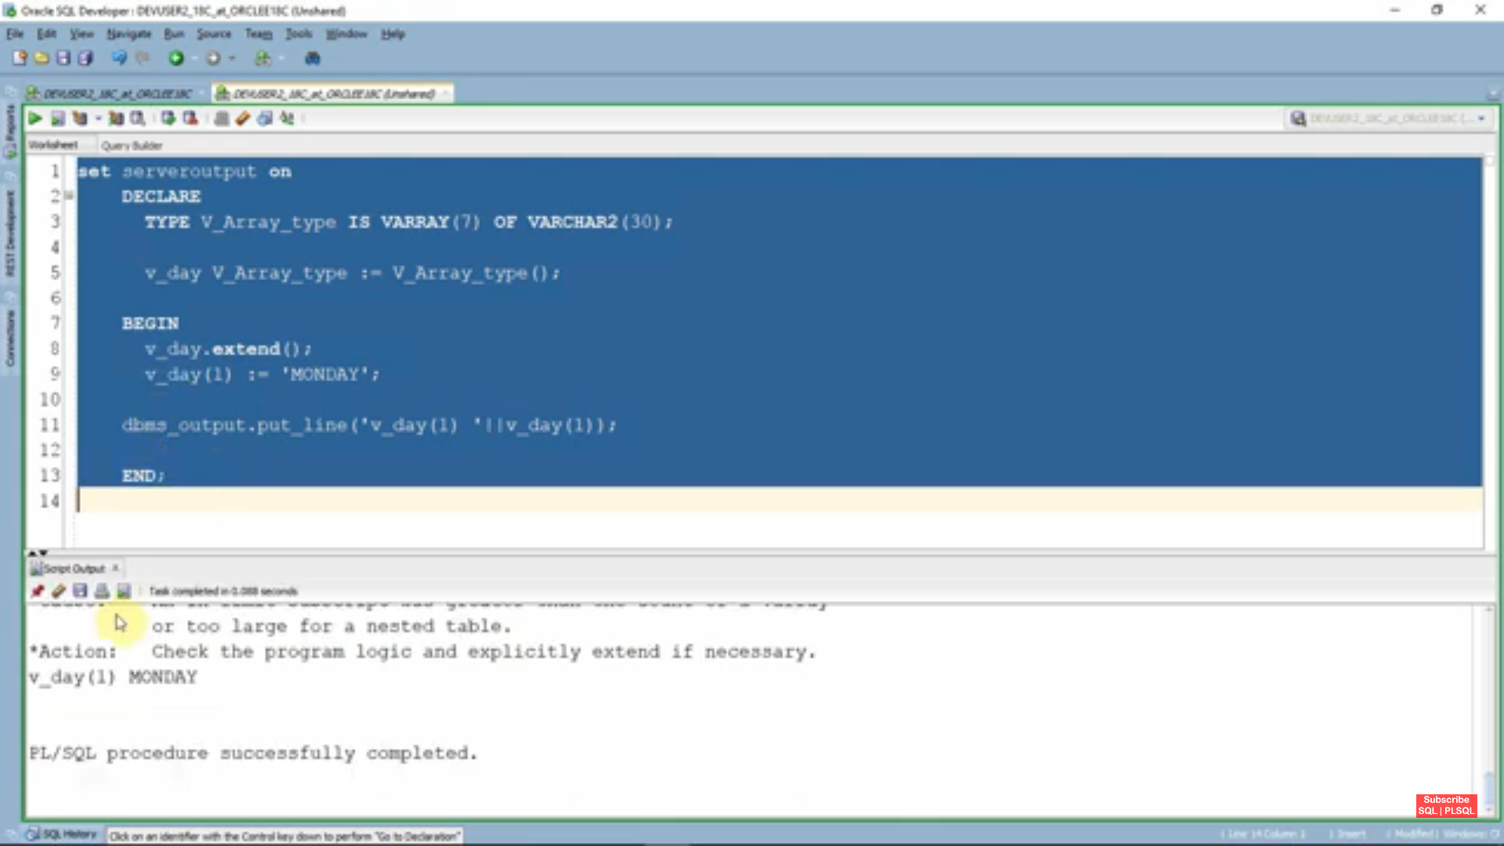

**If we use extend(2) we can assign two elements to that array otherthan two exceeds it gives error like Subscript Beyond count**

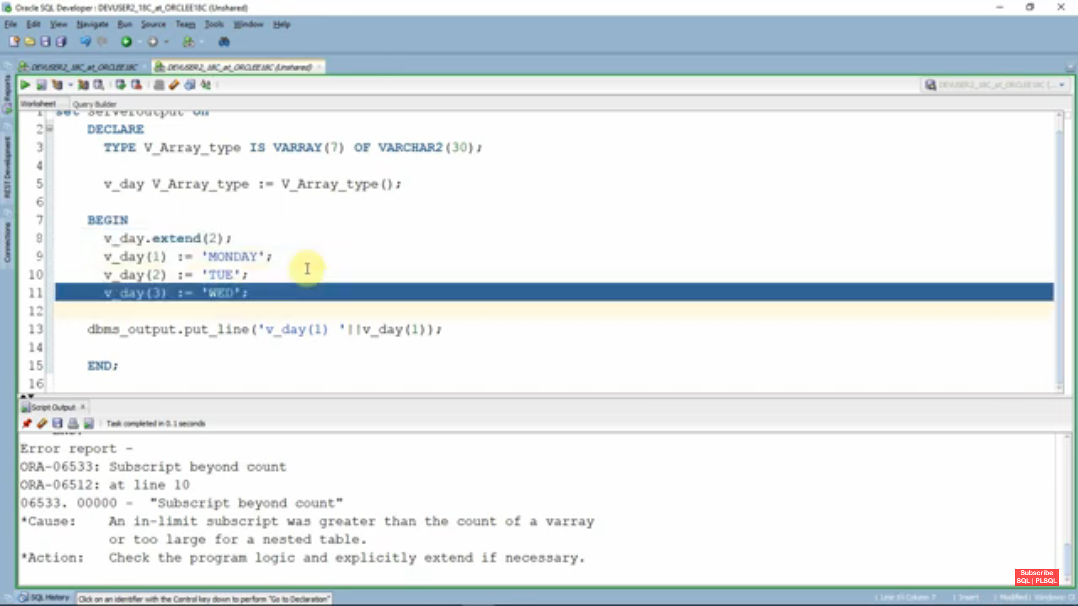

**3rd exception:-**if we try to extend array more then specified value in then it will give error Subscript outside of limit

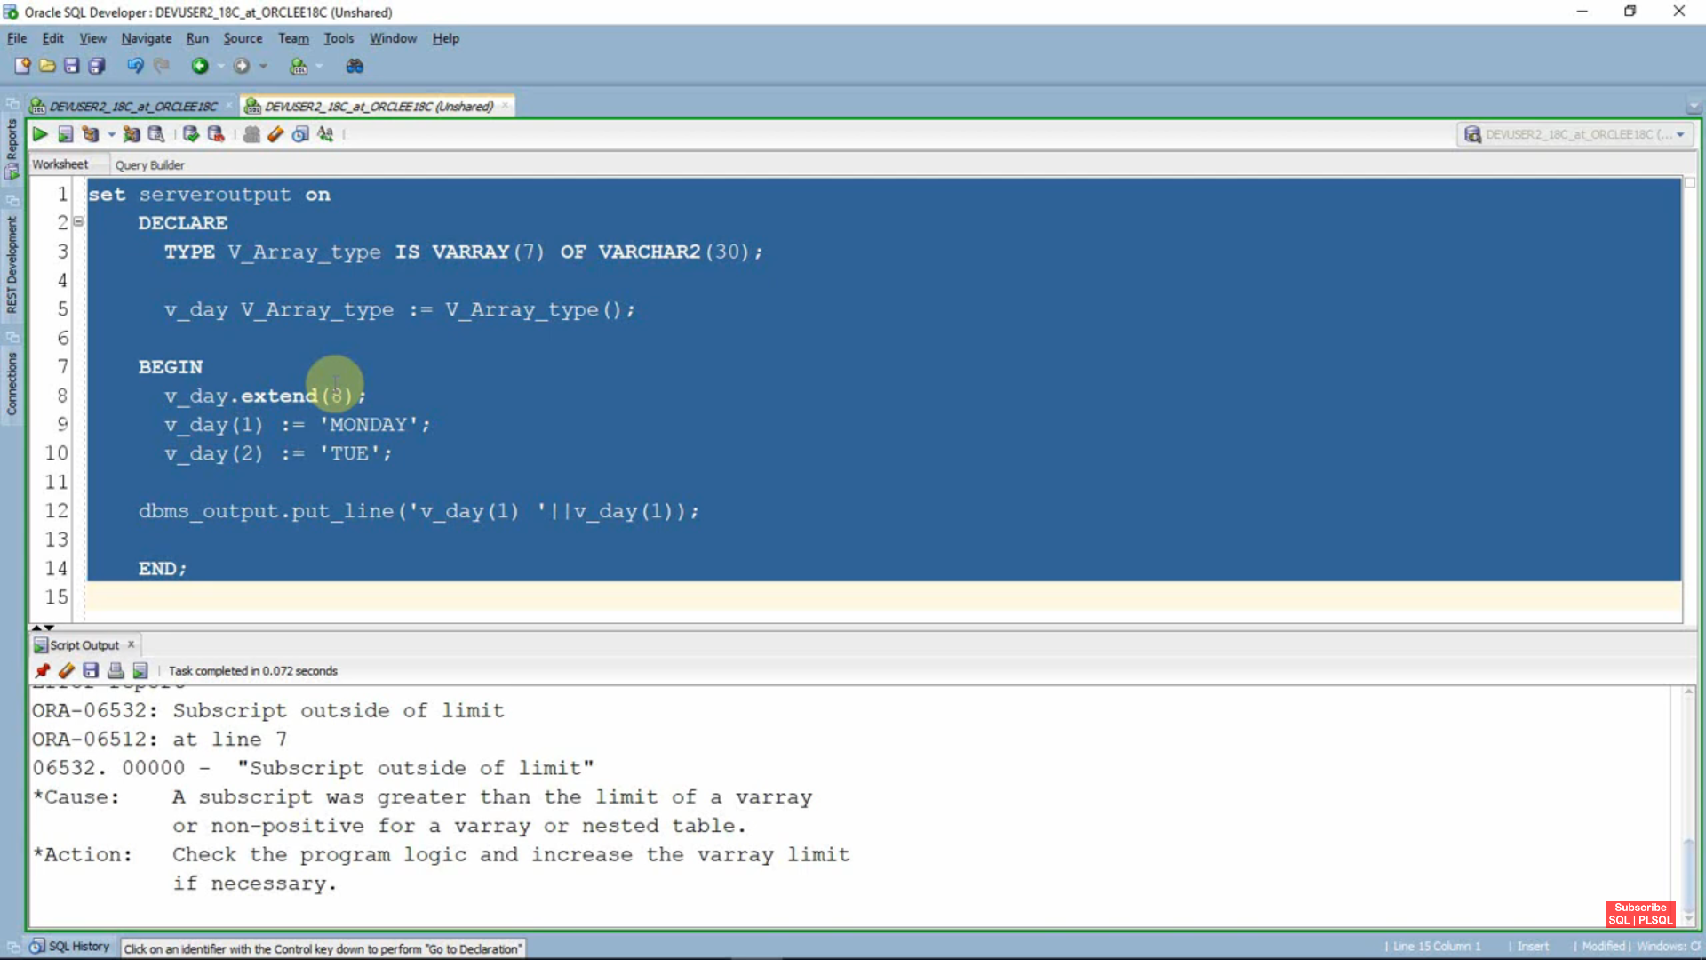

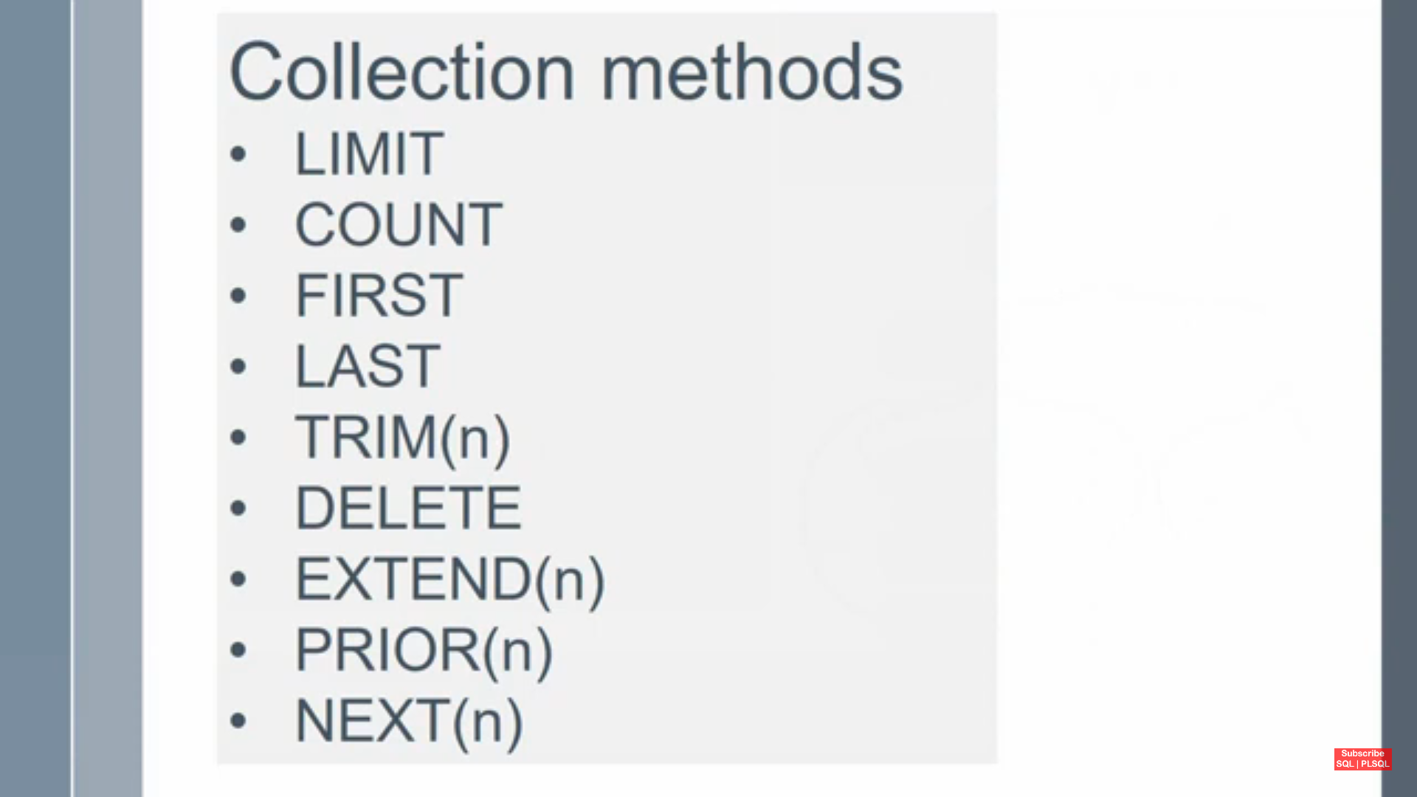

Limit->maximum elements we can store in the Varray.

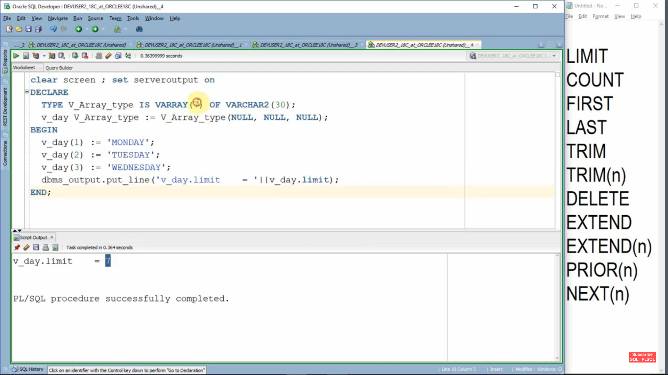

Count

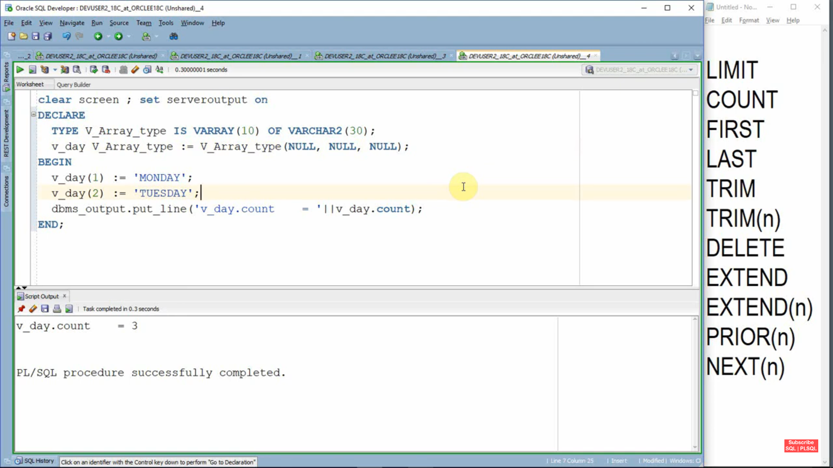

**First**

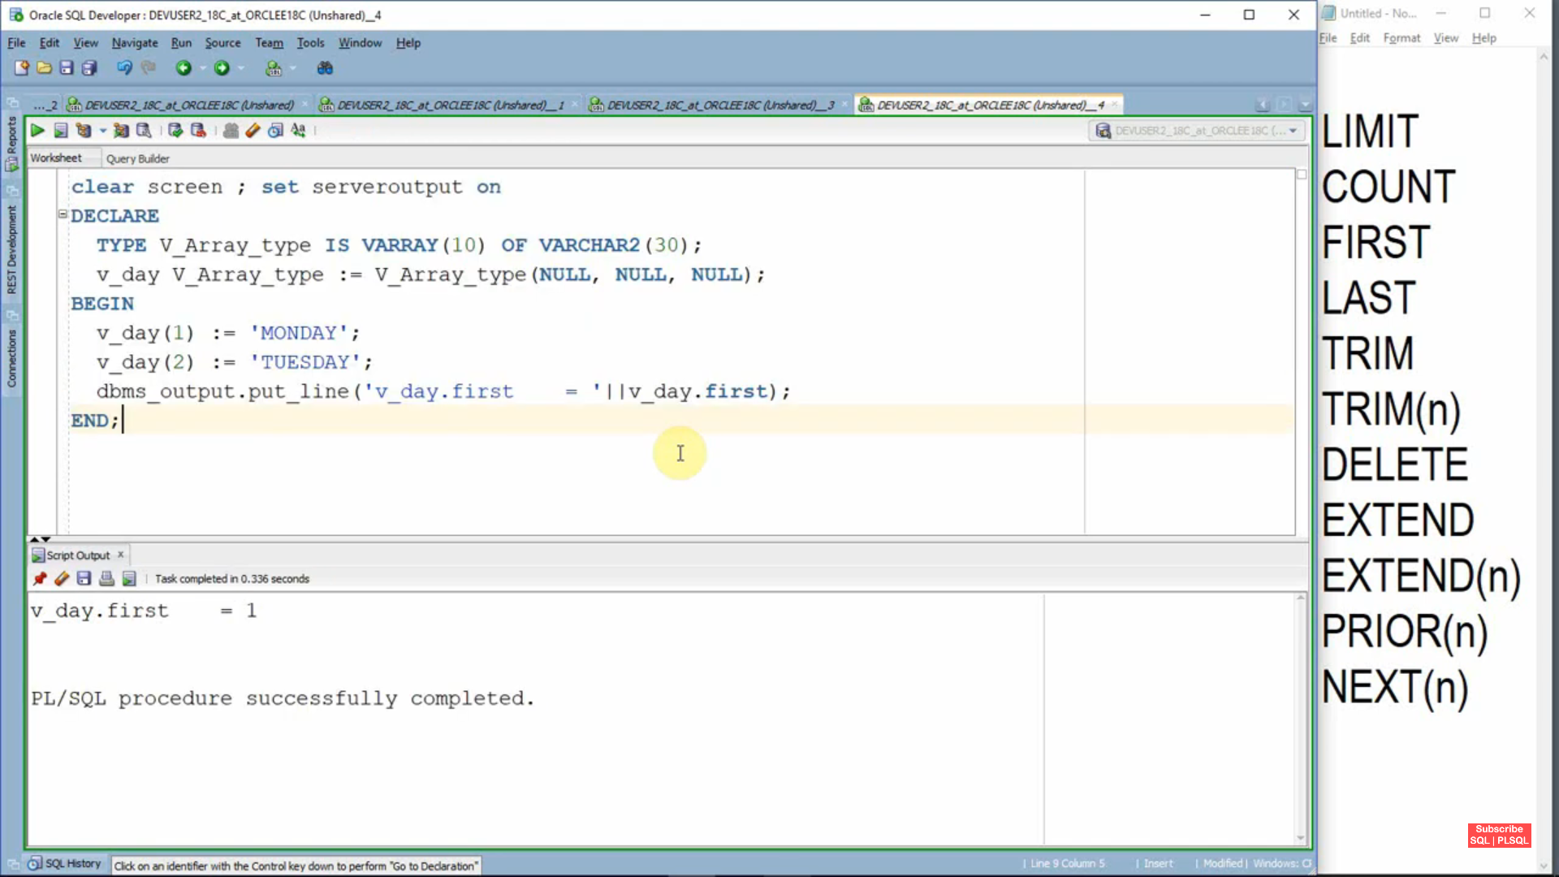

**Last**

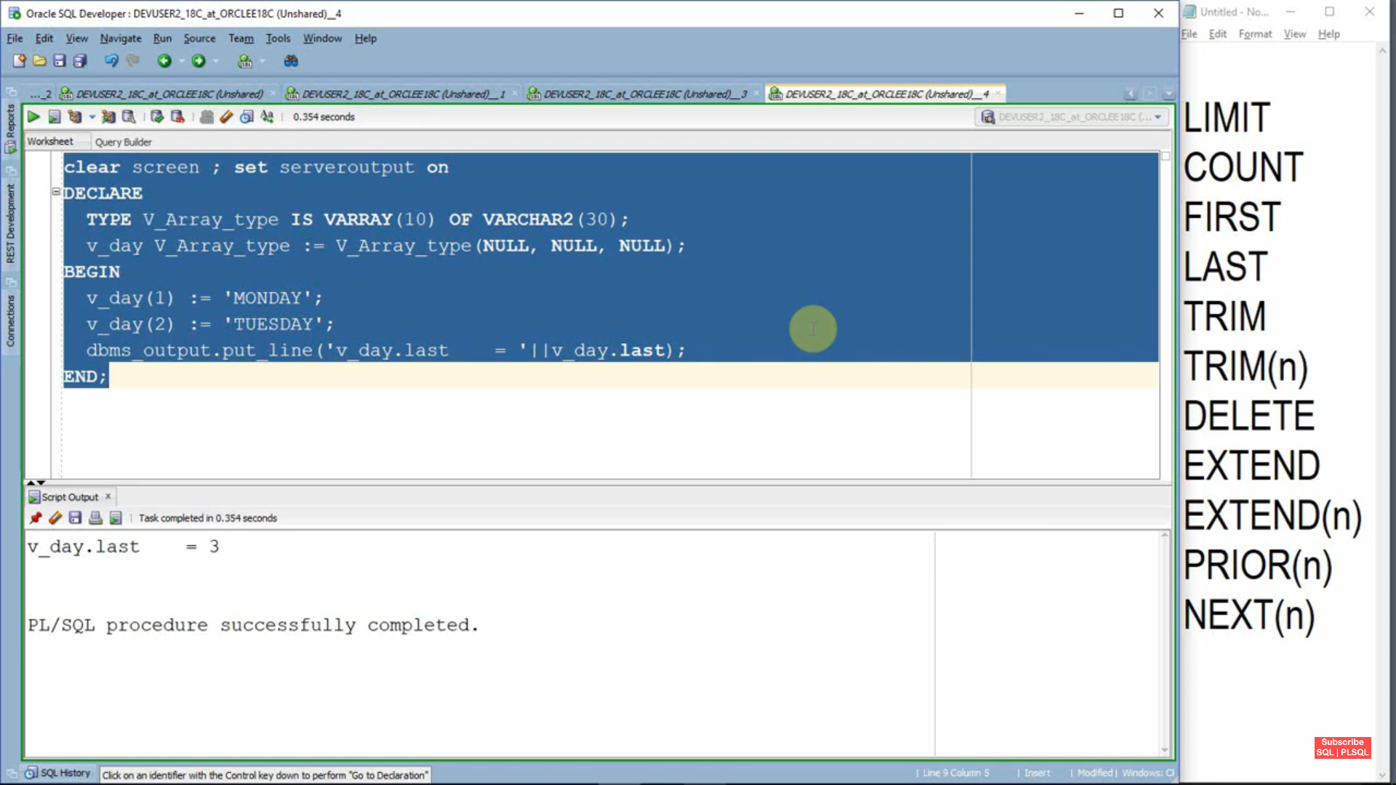

**Trim**

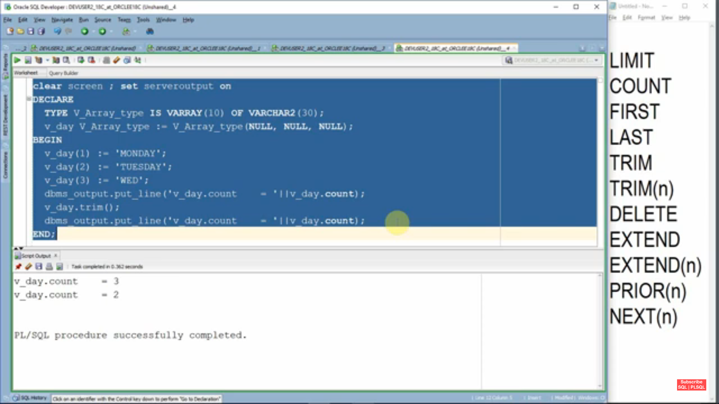

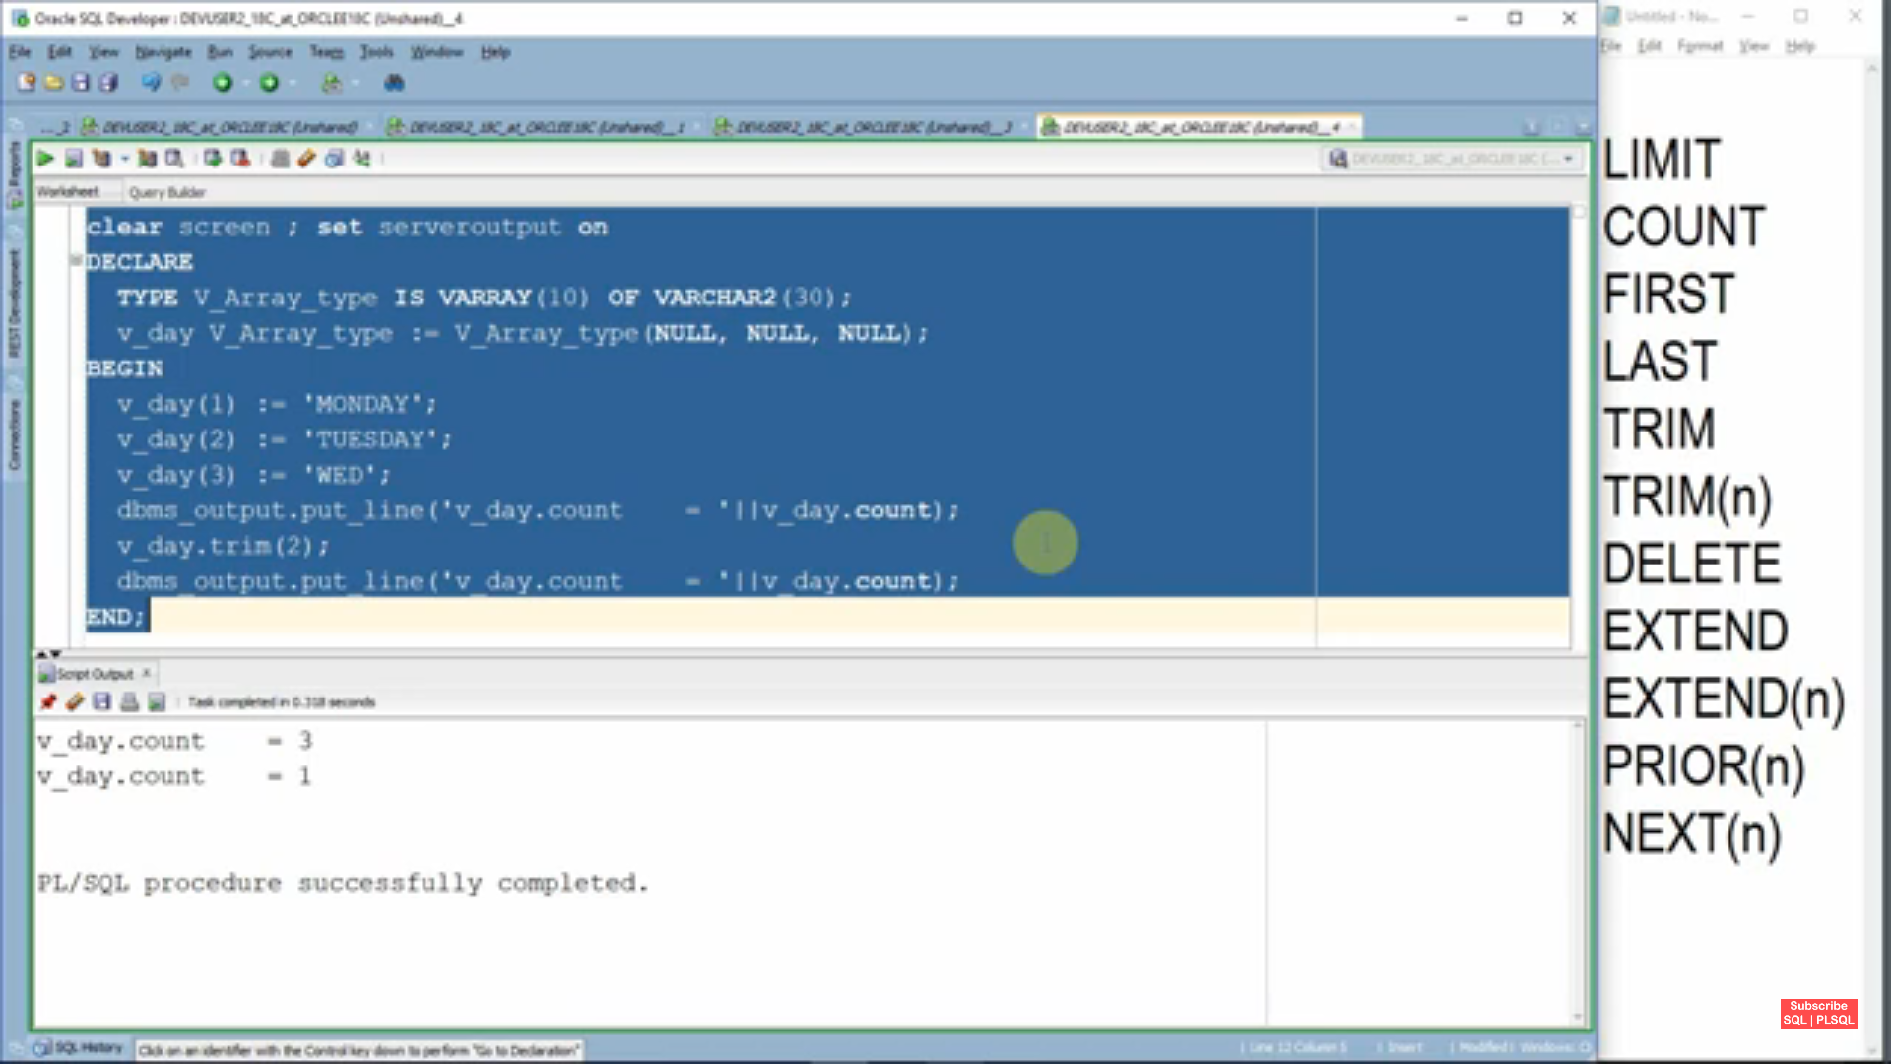

**Delete->Delete all elements in array but trim we can delete specific element in array**